**Capacity Utilization Analytics - Manufacturing Sector**

GOKULNATH K & E24755

**Overview**

Capacity utilization analytics in the manufacturing sector helps data analysts measure how efficiently production resources are being used compared to their maximum potential. It involves analyzing production output against capacity, identifying underutilized equipment or bottlenecks, and optimizing workflows for better efficiency. Insights from this analysis enable businesses to improve resource allocation, reduce operational costs, and increase overall productivity.

**Objective**

1. Measure production efficiency by comparing actual output with maximum capacity.
2. Identify underutilized resources to optimize equipment and workforce usage.
3. Detect bottlenecks in production processes that limit efficiency.
4. Forecast demand to adjust capacity planning and ensure alignment with production goals.
5. Reduce operational costs by improving resource allocation and minimizing waste.

**Assigned Task(s)**

* Capacity Utilization Analytics - Manufacturing Sector.

**Task Details**

* **Task 34 :** Capacity utilization analytics in the manufacturing sector helps data analysts assess how effectively production resources are used, identifying inefficiencies and optimizing operations. It drives improvements in resource allocation, productivity, and cost reduction.
* **Status:** Completed.
* **Details:**

1. Import Libraries: Loaded numpy, pandas, matplotlib, and seaborn.
2. Analyzed a dataset with 100 days of random production data for machines and shifts.
3. Compiled data into a Pandas DataFrame with relevant columns.
4. Calculate Capacity Utilization: Computed utilization using the formula:  
   Capacity Utilization=(Production Hours/Max Capacity Hours)×100.
5. Calculated average capacity utilization for each machine.
6. Generated a bar plot to display average utilization by machine.
7. Filtered machines with average utilization below 70% and printed the results.
8. Create a visualization in units produced vs capacity utilization.
9. Created a visualization on units produced by shifts.
10. Using joint plots to create capacity utilization vs production hours.
11. Visualization on daily capacity utilization on trend per machine.

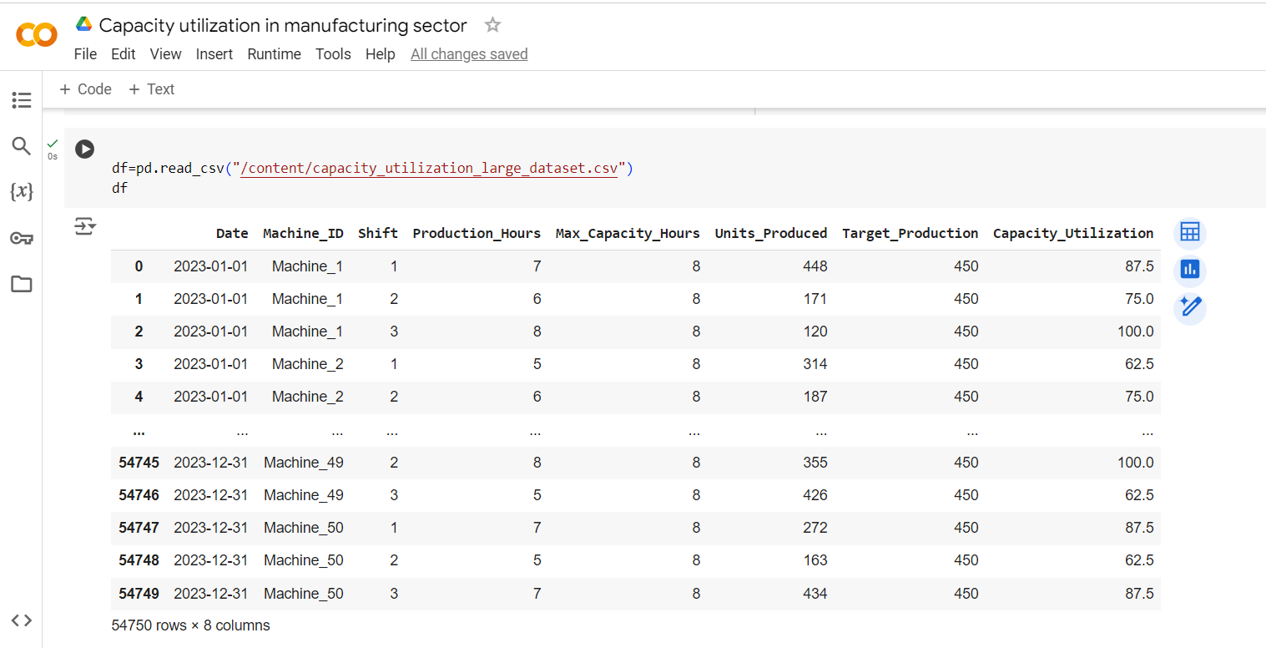

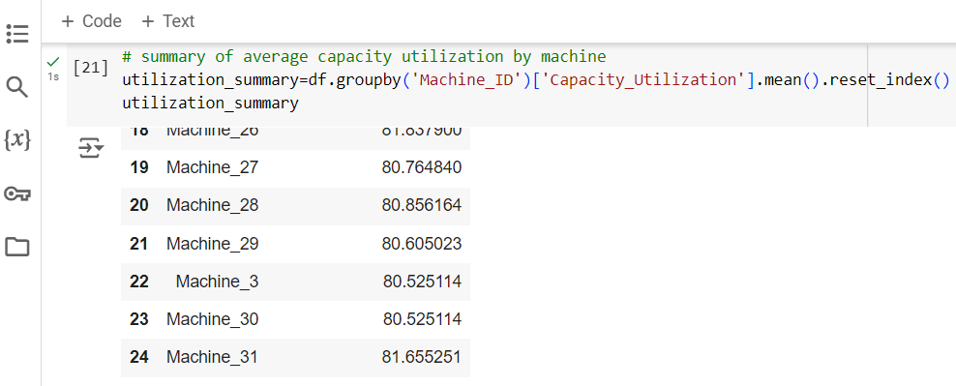

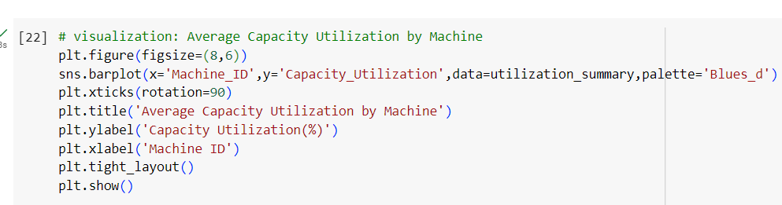

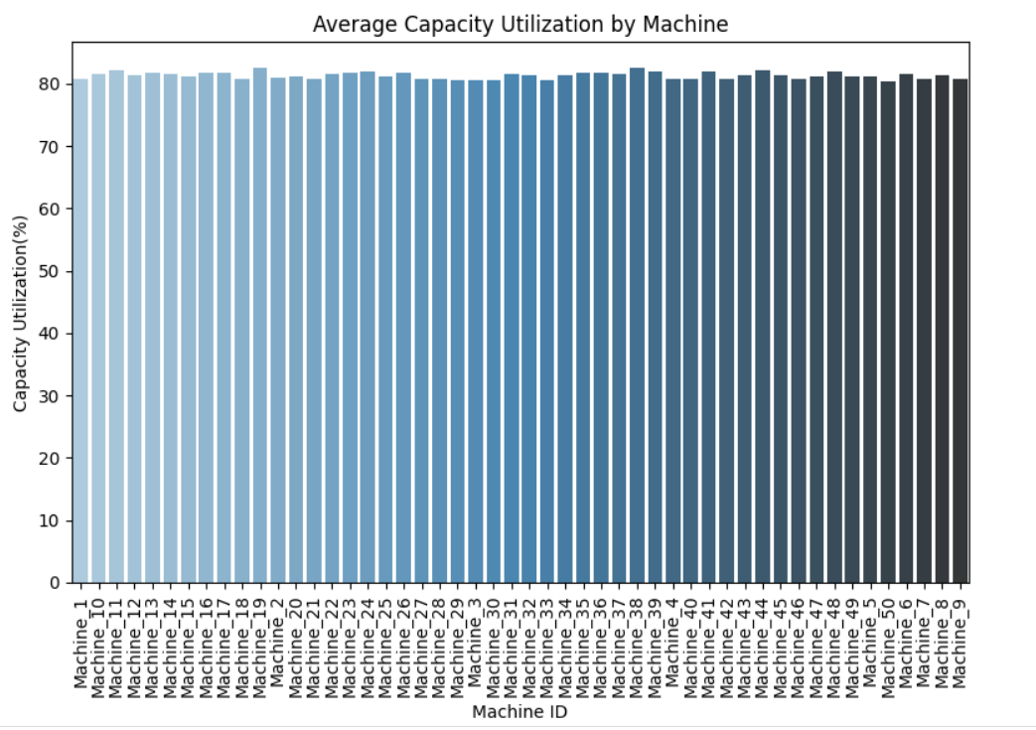

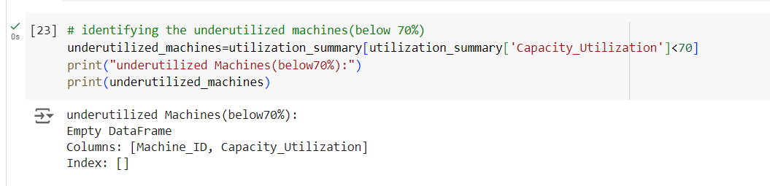

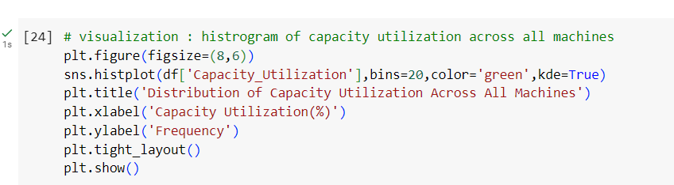

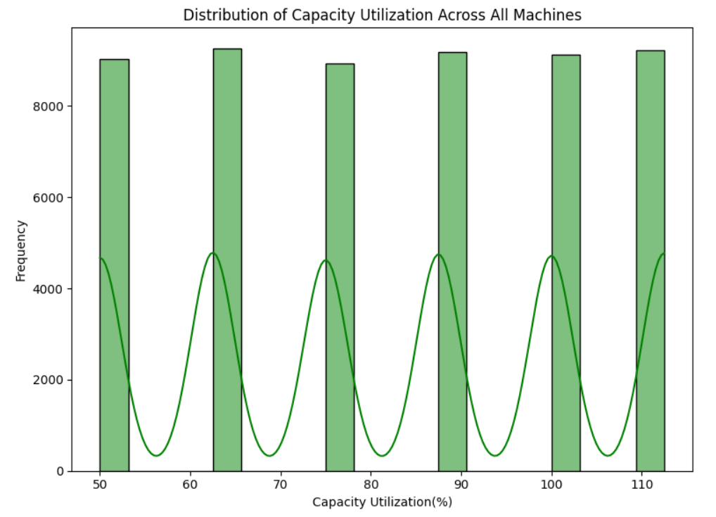

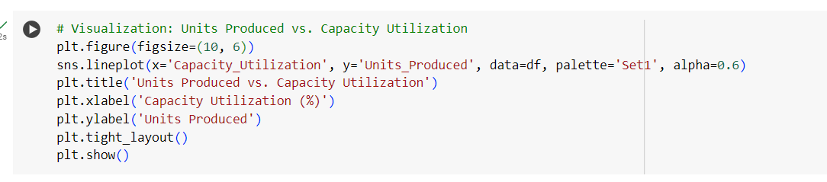

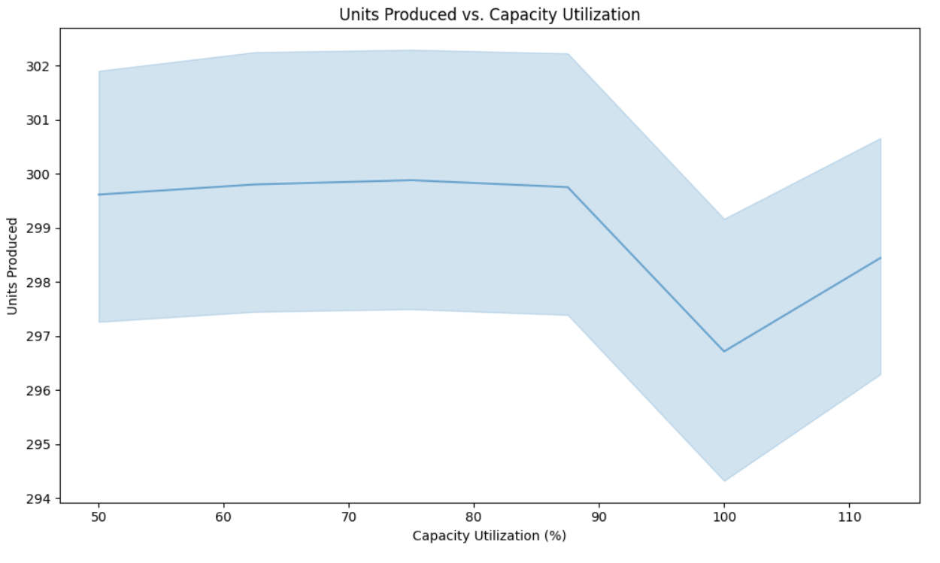

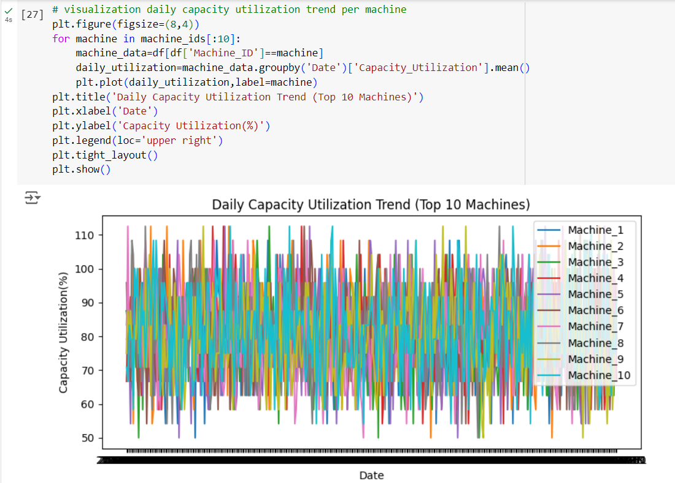

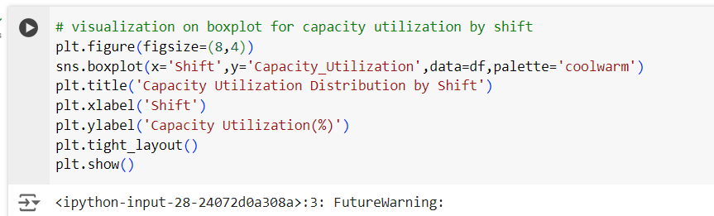

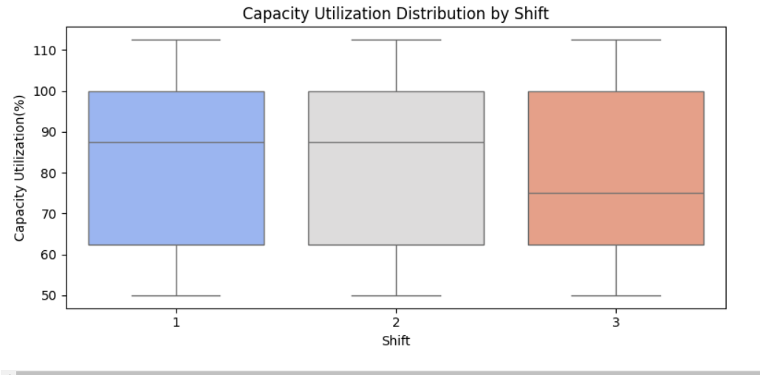

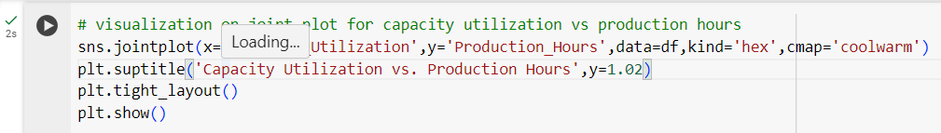

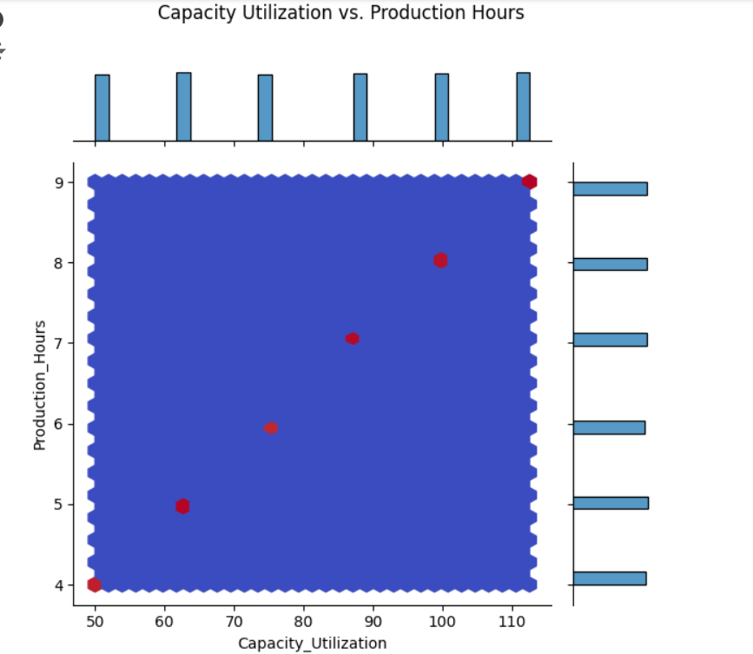

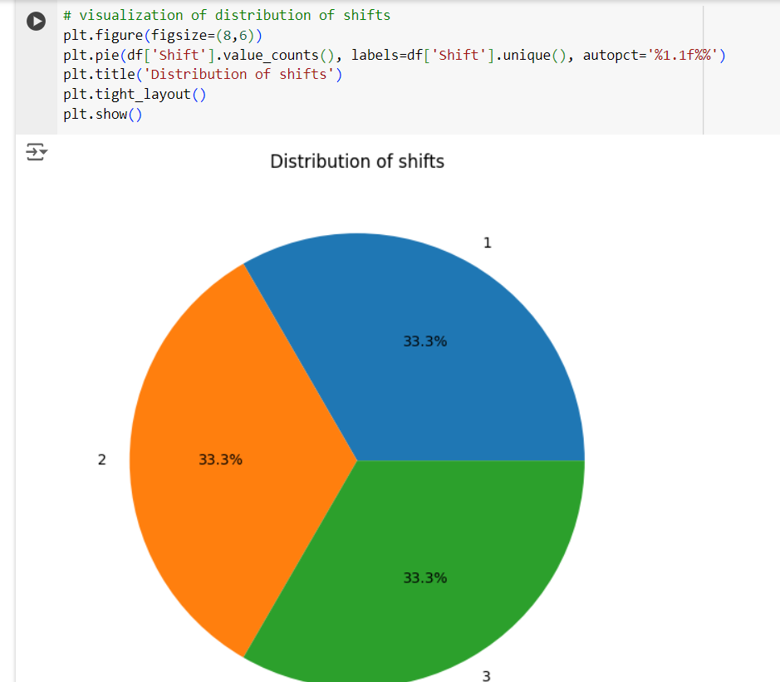

**Progress**

* **Accomplishments:**Accomplished capacity utilization analysis by generating a synthetic dataset, calculating utilization metrics, visualizing trends, and identifying underutilized machines to enhance operational efficiency.
* **Metrics:**

1. Percentage of actual production hours versus maximum available hours.
2. Mean operational hours across machines and shifts.
3. Total number of units produced within a specified period.
4. Comparison of actual production against target units.
5. Percentage of machines operating below a defined utilization threshold (e.g., 70%).
6. Ratio of actual output to potential output, highlighting efficiency in production processes.
7. Amount of time machines are not operational, impacting overall capacity utilization.

**Challenges and Solutions**

* **Challenges Faced:**

1. Fluctuations in demand and production schedules can affect capacity planning.
2. Unscheduled maintenance or breakdowns can significantly reduce capacity utilization
3. Employees may resist new processes or technologies aimed at improving utilization.

* **Solutions Implemented:**

1. Employ predictive analytics to better anticipate demand fluctuations and adjust production plans accordingly.
2. Establish a preventive maintenance schedule to minimize machine downtime.
3. Foster a culture of continuous improvement and provide training to ease the transition to new processes.

**Next Steps**

* **Upcoming Tasks:** Collect, clean, and analyze Manufacturing data to focus on developing data.
* **Goals:** Continuously improving my skills related to the Manufacturing sector.

**Conclusion**

* **Summary:** Capacity utilization analysis is vital for improving operational efficiency in the manufacturing sector. By measuring utilization rates, organizations can identify underperforming machines and optimize resource allocation. Implementing data-driven strategies and predictive analytics leads to enhanced productivity and reduced downtime, ultimately driving business success and competitiveness.
* **Acknowledgements:** Thank you all for your attention and engagement, I appreciate your interest in the Capacity Utilization analytics in Manufacturing sector.